

LAB EXPERIMENTS

Name : Mannepalli Satwik
Reg No : 192424339
Course Code : CSA1022
Course Name : Software Engineering
Faculty : Dr S Salini

JIRA EXPERIMENTS
1.Create a Kanban Board in Jira
a. Satellite Network Project system Kanban Board as it has To Do, in progress, Done boards.
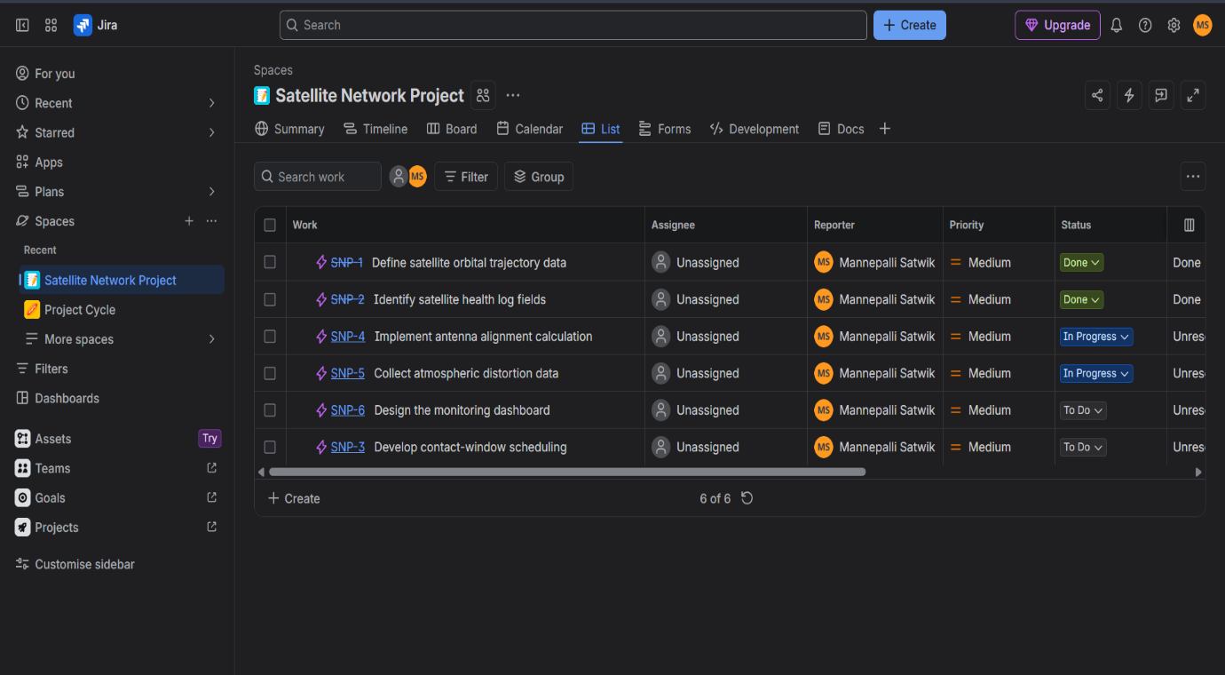

b. This is the Summary board in the project as it shows completed tasks, updated tasks, due time, number of creations.
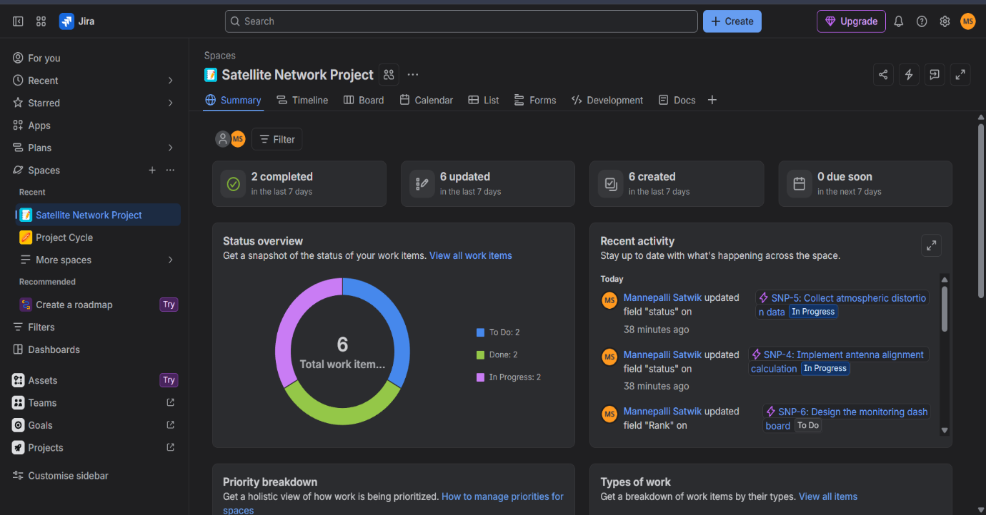

C. This is the List board in Jira where it has what are the works assigned, all details including work, assignee, Reporter, Priority, status, Resolution and due date.
